PROBLEM STATEMENT
Given a generic tree with N nodes, find its maximum height. The integer height of a tree is defined as the depth of the deepest node where depth of a node is defined as the number of nodes it is away from the root, including itself (depth of root is 0).A generic tree or an n-ary tree is a type of tree Data Structure in which each node can have at most n children, and n can be any integer value.
Example: the height of the below tree in terms of nodes is 3
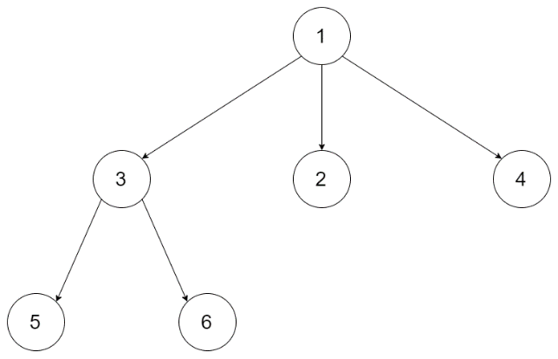

Note: The input is a level order serialization of the tree, where each group of children is separated by the "null" value.

INPUT FORMAT
The first line contains a lever order serialization of the generic tree, where each group of children is separated by the "null" value.

OUTPUT FORMAT
Print an integer representing the height of generic tree

CONSTRAINTS
0 <= N <= 10^4

SAMPLE TESTCASE 0
Testcase Input
[10,null,20,30,40,null,50,60,null,70,80,90,null,100]
Testcase Output
3
Explanation
The tree has three levels: [10], [20, 30, 40] and [50, 60, 70, 80, 90, 100] respectively.
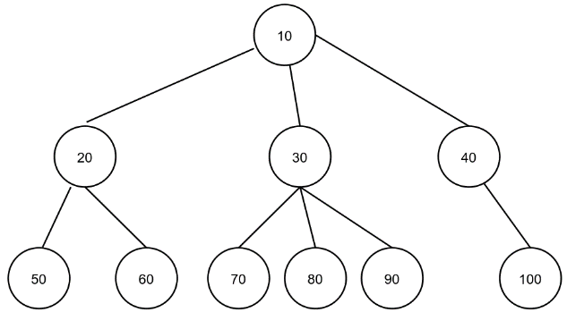

SAMPLE TESTCASE 1
Testcase Input
[1,null,3,2,4,null,5,6]
Testcase Output
3
Explanation
Tree has three levels: [1], [3,2,4] and [5,6] respectively.
